Task 6

6. Conditional Rendering

Tasks:

1. Design a UserStatus component that displays “Online” or “Offline” based on

a isOnline prop.

**UserStatus.jsx**

import React from 'react'

export default function UserStatus(props) {

return (

<>

<h2>{props.name}</h2>

<p>{props.isonline ? "Online" : "Offline"}</p>

</>

)

}

**Main.jsx**

import UserStatus from './UserStatus.jsx'

createRoot(document.getElementById('root')).render(

<StrictMode>

<UserStatus name="Kavin" isonline = {false} />

</StrictMode>

)

**Output**

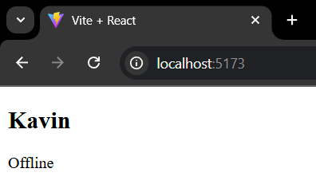

2. Write a component AgeCheck that displays “Adult” or “Minor” based on

an age prop.

**AgeCheck.jsx**

import React from 'react'

export default function AgeCheck(props) {

return (

<>

<h1>{props.age >= 18 ? "Adult" : "Minor"}</h1>

</>

)

}

**Main.jsx**

import AgeCheck from './AgeCheck.jsx'

createRoot(document.getElementById('root')).render(

<StrictMode>

<AgeCheck age={20} />

</StrictMode>

)

**Output**

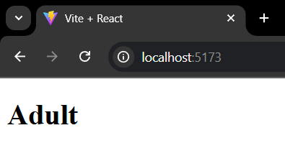

3. Create a Loading component that either displays “Loading…” or content based

on a isLoading prop.

**Loading.jsx**

import React from 'react'

export default function Loading(props) {

return (

<>

<h2>{props.isLoading ? props.isLoading : "Loading"}</h2>

</>

)

}

**Main.jsx**

import Loading from './Loading.jsx'

createRoot(document.getElementById('root')).render(

<StrictMode>

<Loading isLoading="React is a JavaScript library primarily used for building user interfaces (UIs) for web applications"/>

<Loading />

</StrictMode>

)

**Output**

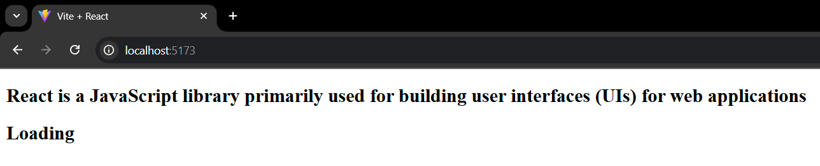

4. Make a Notification component that conditionally displays a message if

a message prop is provided.

**Notification.jsx**

import React from 'react'

export default function Notification(props) {

return (

<>

<h2>{props.content ? props.content : "No Message Available"}</h2>

</>

)

}

**Main.jsx**

import Notification from './Notification.jsx'

createRoot(document.getElementById('root')).render(

<StrictMode>

<Notification content="React is a JavaScript library primarily used for building user interfaces (UIs) for web applications"/>

<Notification />

</StrictMode>

)

**Output**

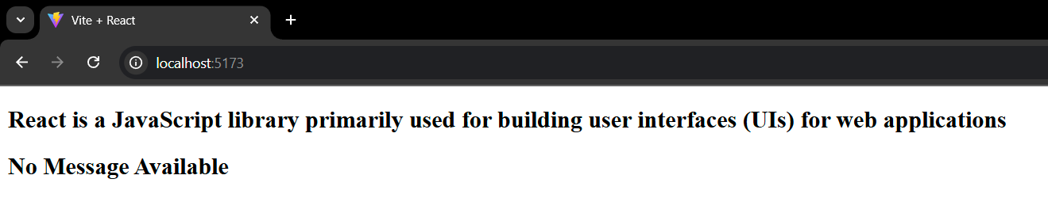

5. Design a Feedback component that displays feedback in either green (positive)

or red (negative) based on a type prop.

**Feedback.jsx**

import React from 'react'

export default function Feedback(props) {

const style = {

color : props.type === "positive" ? "green" : "red"

}

return (

<>

<h2 style = {style} > {props.info}</h2>

</>

)

}

**Main.jsx**

import Feedback from './Feedback.jsx'

createRoot(document.getElementById('root')).render(

<StrictMode>

<Feedback type="positive" info="React is cool"/>

<Feedback type="negative" info="React is bad"/>

</StrictMode>

)

**Output**

